Boolean Logic Operators

Topics

1 Introduction

2 What is a Boolean Statement?

3 Boolean Operators

4 Truth Tables

5 Laws of Boolean Algebra

6 Venn Diagrams & Boolean Algebra

7 Sample Boolean Problems

8 The Boolean Data Type

9 Boolean Logic Exercises

1 Introduction

A century ago there was a mathematician, George Boole, who took statements and wrote them in a precise format, such that a statement is always true or false. He founded a branch of mathematics called Boolean Algebra. Statements that are either true or false are called Boolean statements. The conditions you use with selection and repetition are all Boolean statements.

2 What is a Boolean Statement?

A good starting point is to look at a variety of English sentences and determine if these sentences are Boolean statements or not. So, what is the criteria for a Boolean statement? The sentence, statement, condition, whatever, must be true or false. No questions, no ambiguities, no arguments. You can see why this branch of mathematics has a major impact on computer science. The basis of processing data is the binary system of on and off, which certainly sounds a bunch like true or false.

Each one of the following five statements is a Boolean statement.

A mile is longer than a kilometer.
July and August both have the same number of days.
A pound of feathers is lighter than a pound of lead.
The Moon is larger than the Sun.
New York City has more people than Baltimore.

The five sentences may not have seemed very Boolean to you. Let us look at the sentences again, translate them into brief logic statements, and indicate whether the statement is true of false. Some C++ relational operators are used for the Boolean statements to help clarify the meaning.

English Sentence | Boolean Statement | T/F
A mile is longer than a kilometer. | Mile > Kilometer | True
July and August have the same days. | JulDays == AugDays | True
A pound of feathers is lighter than a pound of lead. | PoundF < PoundL | False
The Moon is larger than the Sun. | MoonSize > SunSize | False
New York City has more people than Baltimore. | NYPop > BaltPop | True

Sentences are not always so short and straightforward. Frequently there are multiple conditions in one statement. Special rules need to be followed to determine if the entire statement is true or false. Consider the following sentences with compound conditions.

She is a computer science teacher and she is a math teacher.
The number is odd or the number is even.
Enter again if gender is not male or gender is not female.
Employment requires a CPA and five years experience.

The same sentences converted into Boolean statements are:

(She == CSTeacher) and (She == MathTeacher)
(Number%2 == 1) or (Number % 2 != 1)
(Gender != Male) or (Gender != Female)
(CPA == "Y") and (YrExp >= 5)

These statements are certainly more complex than the earlier examples. Keep in mind that Boolean statements can be made considerably more complicated

3 Boolean Logic Operators

Here we will look at four different Boolean operators. You know how to handle arithmetic operators ( + - * / ). Addition, subtraction, multiplication and division are performed according to the rules for each operator. There is also a set of Boolean operators with their own set of rules. The rules of Boolean logic operators can be conveniently displayed in a truth table. This is a table that shows the possible combinations of a Boolean statement and indicates the value (true or false) of each statement.

In the truth tables that follow, a single letter indicates a single, simple Boolean condition. Such a condition is either true or false. Boolean statement A is true or false. Likewise Boolean statement B is true or false. The truth tables will show the results of Boolean statements that use both A and B with a variety of Boolean operators. Employment requirements will be used to explain the logic of each truth table. In each case imagine that an accountant needs to be hired. Condition A determines if the applicant has a Degree and condition B determines if the applicant has at least five years experience.

Boolean Or

The or Operator
A | B | A or B
T | T | T
T | F | T
F | T | T
F | F | F

Notice that two conditions have four possible combinations. It is important that you know the results for each type of combination.

In this case the employment analogy requires a Degree OR Experience. This requirement is quite relaxed. You have a Degree, fine. You have Experience, that’s also fine. You have both, definitely fine. You have neither, that’s a problem.

Boolean And

The and Operator
A | B | A and B
T | T | T
T | F | F
F | T | F
F | F | F

Now employment requires a Degree AND Experience. This requirement is much more demanding than the or operator. You have a Degree, fine, provided you also have Experience. If you have only one qualification, or the other qualification, that is not good enough. If you have neither qualification, forget showing up.

Boolean Xor

The xor Operator
A | B | A xor B
T | T | F
T | F | T
F | T | T
F | F | F

Everyday language uses both the or operator, as well as the and operator. How about the “exclusive or” xor? A peek at the truth table shows something pretty weird. If conditions A and B are both true, the compound result is false. I will try to explain this by using the “cheap boss” analogy. A manager wants to hire somebody and not pay much money. The advertisement states that a degree or experience is required.

Candidate X walks in and the boss says: “I’ll hire you, but your pay will be low. You see, you have a degree but you have no experience at all.”

Candidate Y walks in and the boss says: “I’ll hire you, but your pay will be low. You see, you have experience but you have no degree.”

Candidate Z walks in and the boss says: “I’m sorry I cannot hire you. You are over qualified since you have a degree and also experience.”

Let us try another example with a “Student Council” election analogy. The student council sponsor requires that a candidate shows school spirit by belonging to a musical organization (band, orchestra, choir) or an athletic team. You can only run for student council if you belong to one or the other group. However, if you are active in both a musical organization and an athletic team, the sponsor does not want you in Student Council. You are too active and won’t have the time to do a proper job.

Boolean Not

The not Operator
A | not A
T | F
F | T

This section will finish with the simplest Boolean operator, not. This operator takes the condition that follows and changes true to false or false to true. There are special rules that need to be followed when a complex Boolean statement is used with not. Such rules will be explained later in the chapter. Right now we want to understand the simple truth table shown above. In English we need to use “double negative” sentences to create an appropriate analogy. I can say “It is not true that Tom Smith is valedictorian.” This statement results in Tom not being Valedictorian. On the other hand, if I say “It is not true that Tom Smith is not the Valedictorian.” Now Tom is the Valedictorian.
4 Truth Tables

Truth tables provide a convenient way to decide when a Boolean expression is true, and if an expression is equivalent to another Boolean expression. The last section introduced simple truth tables to explain the Boolean operators. Now we are going to look at more complex Boolean statements with the help of more complex truth tables. The Boolean statements will not only be more complex, we will also consider a larger number of different conditions.

Let us start with the statement (A and B) or B, shown in Truth Table #1

Truth Table #1
A | B | A and B | (A and B) or B
T | T | T | T
T | F | F | F
F | T | F | T
F | F | F | F
Does this truth table tell us anything? It may look just like a bunch of Ts and Fs to you, but perhaps you notice something else. The compound Boolean statement of (A and B) or B has the same truth table as B. Forget A. The value of A is totally irrelevant. If B is true the whole enchilada is true.

That was a pretty good warm up. How about the statement (A and B) or C ? The statement is similar to the previous problem, but now a third Boolean operand is introduced. This third operand suddenly changes the rules considerably. With two operands (A and B) there are four possible combinations to consider. Now that we have three operands (A, B and C), the Truth Table #2 will need to consider eight different possibilities.

Truth Table #2
A | B | C | A and B | (A and B) or C
T | T | T | T | T
T | T | F | T | T
T | F | T | F | T
T | F | F | F | F
F | T | T | F | T
F | T | F | F | F
F | F | T | F | T
F | F | F | F | F

Do you feel that any profound observations can be made about the truth table above? Probably not. Consider a similar Boolean statement with altered operators in Truth Table #3.

Truth Table #3
A | B | C | A or B | (A or B) and C
T | T | T | T | T
T | T | F | T | F
T | F | T | T | T
T | F | F | T | F
F | T | T | T | T
F | T | F | T | F
F | F | T | F | F
F | F | F | F | F

You might observe that C must be true, otherwise the entire statement cannot be true. So what is the point here? The point is somewhat obscure. There are Boolean rules that most people would not expect. In fact, a lot of people find some of the rules pretty weird and do not believe them. With the use of truth tables these rules can be proven. How? Because of the following truth table fact.

Truth Table Fact
The truth tables of equivalent Boolean expressions are
identical.

Boolean expressions that use the not operator often create the most confusion and mistakes in computer science. In Boolean Algebra the tilde ( ~ ) is used for the not operator. Consider the following expression:

~ (A or B)

For reasons unknown I have the desire to remove the parentheses and still maintain a Boolean expression with the same value. Armed with high school Algebra, I cleverly use the distributive property and create the following:

~A or ~B
It is just terrific that I used the distributive property to make the decision that the Boolean Expression ~ ( A or B ) is equivalent to ~A or ~B. This type of logic works fine in Algebra, but we are doing Boolean Algebra. What comes to our rescue are the trusty truth tables. I will just create a truth table for each one of the expressions and compare the values.

Truth Table #4
A | B | A or B | ~(A or B) | ~A | ~B | ~A or ~B
T | T | T | >F< | F | F | >F<
T | F | T | >F< | F | T | >T<
F | T | T | >F< | T | F | >T<
F | F | F | >T< | T | T | >T<

Truth Table #4 shows that the distributive property logic of regular Algebra does not apply. The truth tables of the two expressions are not equivalent. The final truth tables have been highlighted with arrows. The table {F F F T} is quite different from the table {F T T T}.

The functionality of truth tables perhaps have been demonstrated to you. But now you are very curious. Just exactly what happens when you remove the parenthesis? Regular Algebra is no help, the truth tables confirmed that. How about considering if the Expression ~ ( A or B ) is equivalent to ~A and ~B with Truth Table #5.

Truth Table #5
A | B | A or B | ~(A or B) | ~A | ~B | ~A and ~B
T | T | T | >F< | F | F | >F<
T | F | T | >F< | F | T | >F<
F | T | T | >F< | T | F | >F<
F | F | F | >T< | T | T | >T<

Can you believe it? The two expressions are equivalent. This is entirely too weird, but the facts are staring you straight in the face. Perhaps you can appreciate now why this chapter is needed. Armed with only the rudimentary truth tables of the previous section, you would not simply conclude what was just proven. Lack of this knowledge has negative consequences on your programs and it does not help your AP Examination score much either.

In Truth Table #6 we take a look at a similar problem that at first may look identical. It is a matter of altering the Boolean operands and checking to see if the expression ~ ( A and B ) is equivalent to ~A or ~B.

Truth Table #6
A | B | A and B | ~(A and B) | ~A | ~B | ~A or ~B
T | T | T | >F< | F | F | >F<
T | F | F | >T< | F | T | >T<
F | T | F | >T< | T | F | >T<
F | F | F | >T< | T | T | >T<

Once again, the unexpected (or perhaps by now expected) expressions are equivalent to each other. You have actually been observing one of the more common, and more important laws of Boolean Algebra. We will return to this law later in the chapter and address the rule in a more formal manner.

Right now take a look at Truth Table #7. Everything about the truth table is identical to the previous Truth Table #6. The only difference is that all the Ts and the Fs are gone and in its place are 1s and 0s. It is a very common practice in computer science to equate true with 1, and false with 0. So if you see a truth table with 1s and 0s, do not get excited. It is no big deal.

Truth Table #7
A | B | A and B | ~(A and B) | ~A | ~B | ~A or ~B
1 | 1 | 1 | >0< | 0 | 0 | >0<
1 | 0 | 0 | >1< | 0 | 1 | >1<
0 | 1 | 0 | >1< | 1 | 0 | >1<
0 | 0 | 0 | >1< | 1 | 1 | >1<

11.6 Laws of Boolean Algebra

It is probably difficult to appreciate why exactly you are learning this stuff right now. This all looks like theoretical, mathematical, abstract, who knows what, type of business that appears not to have any connection with computer science. Well congratulations you have arrived at one of the many no-win situations. The no-win is for the illustrious author (me) who cannot present the material without some problems. The next control structures chapter requires an understanding of Boolean logic. If Boolean logic is presented first, there will appear no connection with computer science, especially programming. If advanced control structures are done first, there will be a lack of logical foundation that explains the reasoning for certain control structure behavior. Like I said there is no-winning this situation. Whichever way is ultimately better, at this point I am selecting to present theoretical Boolean Algebra in a chapter by itself.

For the remainder of this chapter, the Boolean operators and, or and not will be replaced by a notation that is commonly used with Boolean expressions. You have already noticed this type of notation for not.

Boolean Algebra Notation
A or B → → A + B
A and B → → A • B → → A * B → → AB
not (A) → → ~A
true → → 1
false → → 0

You noticed that the logical and has multiple symbols. This is very similar to algebraic multiplication, which can be expressed with A × B, A * B or AB. For the Boolean laws that follow, the “asterisk” ( * ) will be used.

The next page present the common laws for Boolean Algebra. Knowing the names of each law is not significant. It is far more important that each law makes sense to you, and that you can apply the law.
Basic Laws of Boolean Algebra
A + A = A  A * A = A  A + B = B + A  A * B = B * A  A + (B + C) = (A + B) + C  A * (B * C) = (A * B) * C  A * (B + C) = (A * B) + (A * C)  A + (B * C) = (A + B) * (A + C)  A + 1 = 1  A * 0 = 0  A * (A + B) = A  A + (A * B) = A  A * 1 = A  A + 0 = A  ~ (~A) = A  A + ~A = 1  A * ~A = 0  ~(A + B) = ~A * ~B  ~(A * B) = ~A + ~B | Idempotent law for or  Idempotent law for and  Commutative law for or  Commutative law for and  Associative law for or  Associative law for and  Distributive law for and over or  Distributive law for or over and  Law of Union  Law of Intersection  Law of Absorption  Law of Absorption  1 is the identity element for and  0 is the identity element for or  Double negative law  Law of Complement for or  Law of Complement for and  DeMorgan’s law  DeMorgan’s law

The whole point of the Boolean Laws is to understand them. Your teacher may decide whether these laws are important enough to discuss individually. But again, the names are not the issue. Consider the Law of Absorption and see if it makes sense.

The Law of Absorption presents the following two expression equivalencies:

A * (A + B) = A
A + (A * B) = A

The Law of absorption basically states that B might as well go home, because the value of B is absolutely of no consequence in the outcome of the expression. Does that make sense? Look at the truth table below to help understand the logic of the absorption law.

A | B | A and B | A or B | A and (A or B ) | A or (A and B)
A | B | A * B | A + B | A * (A + B) | A + (A * B)
1 | 1 | 1 | 1 | 1 | 1
1 | 0 | 0 | 1 | 1 | 1
0 | 1 | 0 | 1 | 0 | 0
0 | 0 | 0 | 0 | 0 | 0

When you follow the truth table you should realize that both expressions are determined by the value of A. Poor B is going along for the ride and can only observe. B’s contribution is ignored. More than anything, the absorption law is an understanding of the and and the or logical operators.

Check each law out, one-by-one, and see if you find the law a logical consequence of the basic rules that were introduced earlier. Many Boolean logic problems can be solved with truth tables, but truth tables are cumbersome and certainly time consuming. An understanding of Boolean Algebra laws creates considerable efficiency when dealing with Boolean problems.

Some of the truth tables in the previous section proved what has now shown to be DeMorgan’s Law. This law is very practical in computer science. In a later chapter we will return to this law and apply its rules to some practical programming code.

11.6 Boolean Algebra & Venn Diagrams

Venn diagrams are useful tools for teaching set theory. With rectangle to represent the universal set and a group of circles, representing individual sets, inside the rectangle, it is possible to visually demonstrate many Set Theory concepts. You probably learned about Venn diagrams in one or more mathematics classes. Boolean Algebra would not have been mentioned in any of these classes and you learned terms like union and intersection. The relationship between Boolean Algebra and Set Theory is very close, and the same visual benefits of Venn diagrams can apply to Boolean Algebra, as well as Set Theory.

Intersection and Logical and
The Boolean Algebra logical and ( * ) can be demonstrated
with Venn Diagrams, using intersection.

Venn Diagram 1 shows the intersection sets A and B. Consider one of the Boolean examples of the past. You have an employment requirement that applicants must have a college degree and they must also have five years of work experience. Now imagine that Set A represents people with a college degree, and Set B represents people with at least five years of work experience. In this case the shaded section is the result of saying A and B in Boolean Algebra or the intersection of Set A and Set B in Set Theory, denoted as A B.

Venn Diagram 1
A and B
A * B
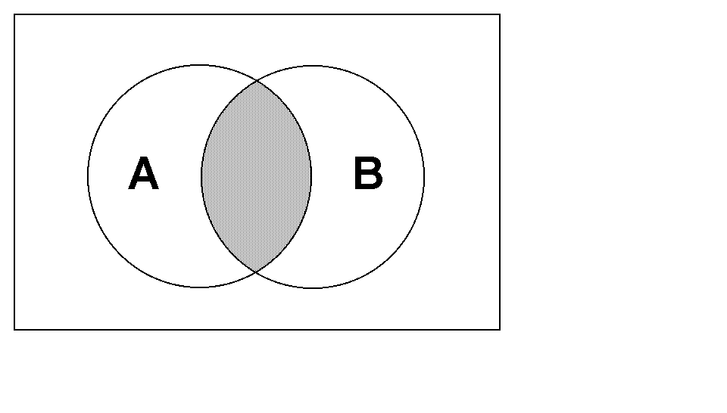

This time our business will hire people that have either a college degree or at least five years of experience. With the logical or there are now many more people qualified to apply for the job. We now can interview everybody in Set A, which are the college degree people as well as everybody in Set B, which are the experience people. In Boolean Algebra this is stated with the expression A or B. In set theory this is called the union of Set A and Set B, or A U B, which is illustrated with Venn Diagram 2.

Venn Diagram 2
A or B
A + B
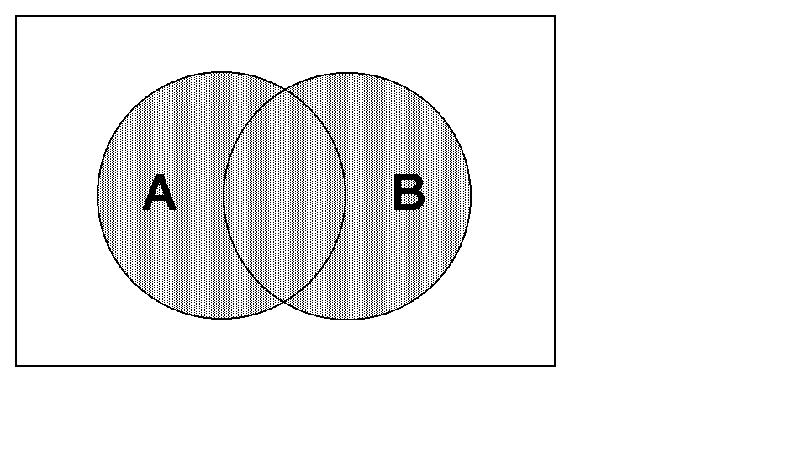

The reason for using Venn diagrams is to help illustrate Boolean Algebra concepts. With small expressions like A and B and A or B you may not see much need for using Venn diagrams. However, more complex expressions can be assisted with the help of set theory. Venn diagrams are particularly helpful to demonstrate that two different expressions are equivalent. You have seen truth tables used for proving equivalent expressions. You can now do the same with the aid of Set Theory and Venn diagrams.

Another benefit is to understand the laws of Boolean Algebra. These laws were presented earlier and while many laws may be easy to understand, there are plenty of obscure looking laws. With the illustrations of Venn diagrams, the correctness of these laws can be illustrated very nicely.

Additional Venn diagram examples will be shown. A few examples will be given that come from the laws of Boolean Algebra, but not every law is going to be illustrated with Set Theory. You will be pleased to know that some of that effort has been reserved for your personal academic motivation level.

Venn diagrams 3 and 4 illustrate the not operator, which is identical in Boolean Algebra, as well as in Set Theory. Expressions not(A) and not(B) are shown in the next two diagrams.

Venn Diagram 3
not(A)
~A
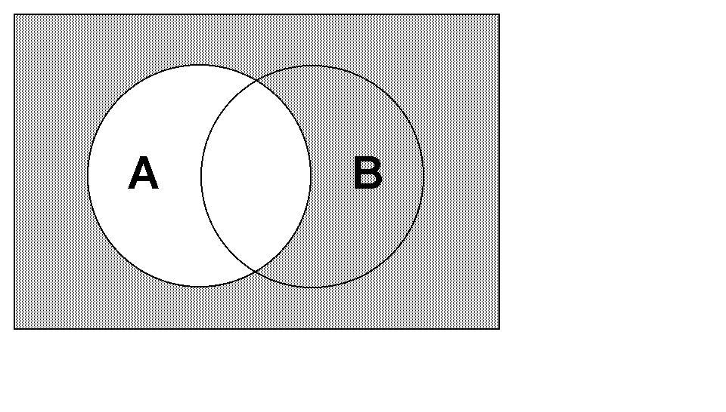

Venn Diagram 4
not(B)
~B
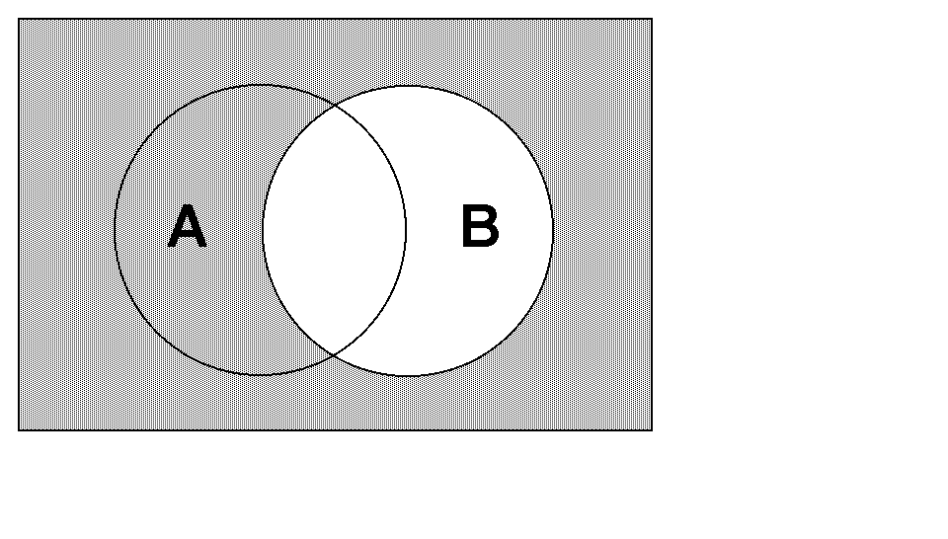

The remaining Venn diagrams will show a variety of compound Boolean expressions. Venn diagram 5 illustrates the negation of the intersection of A and B, which is not(A and B) in Boolean Algebra or ~(A B) in Set Theory.

Venn Diagram 5
not(A and B)
~(A * B)
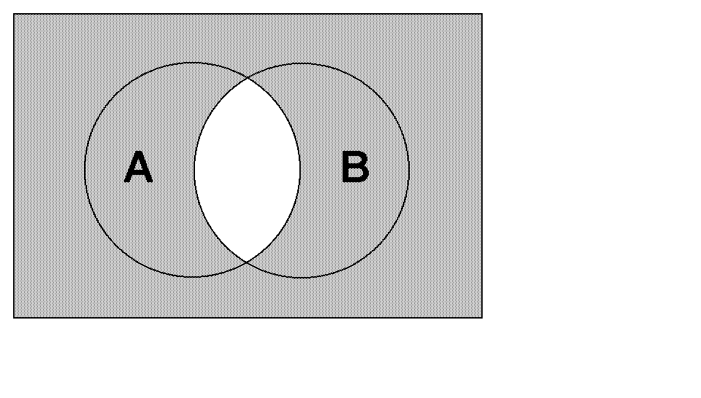

Venn diagram 6 is very similar to the previous example, but this illustrates the negation of the union of Set A and Set B. You can compare diagrams 5 and 6 with the earlier diagrams 1 and 2 to notice the pattern of negation.
Venn Diagram 6
not(A or B)
~(A + B)
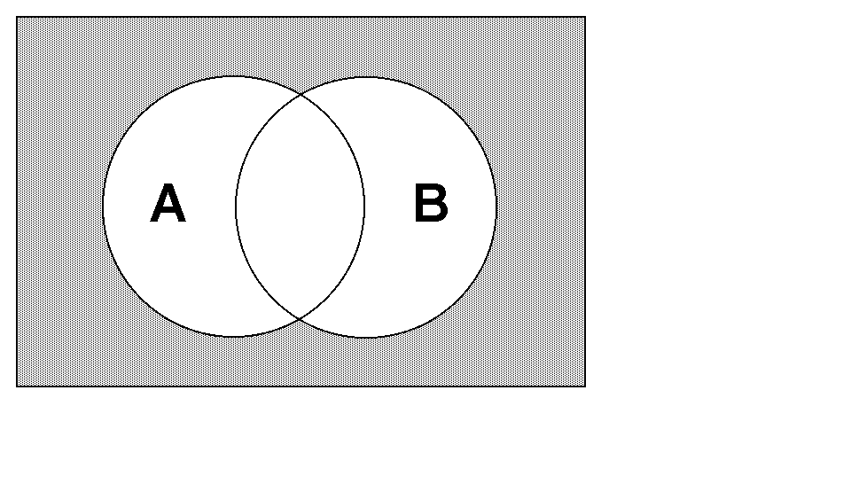

One of the Boolean Algebra Laws is DeMorgan’s Law, which states that the expression not(A or B) is equivalent to the expression not(A) and not(B). The correctness of this law can be tested with truth tables. It can also be illustrates with Venn diagrams. Note that Venn diagram 6 shows not(A or B) and Venn diagram 7 shows not(A) and not(B). Most importantly, note that both Venn diagrams 6 and 7 illustrate the exact same result.

Venn Diagram 7
not(A) and not(B)
~A * ~B


The second part of DeMorgan’s Law states that not(A and B) is equivalent to not(A) or not(B). This law is proven by Venn diagrams 5 and 8. If any of the remaining Boolean Algebra laws confuse you, create Venn diagrams.

Venn Diagram 8
not(A) or not(B)
~A + ~B


11.7 Sample Boolean Problems

In this section a variety of Boolean problems will be presented along with their solution. At the end of the chapter you will be pleased to find another assortment of exercises for your homework entertainment. These problems are quite new and different from the one you have worked in previous chapters. This section is designed to help prepare you for handling the problem in this chapter, and also for the AP Computer Science Examination.

APCS Test Alert
The first group of problems are meant to be simple and straight
forward. These problems are designed to help you understand
Boolean logic better. These problems are not APCS
Examination type problems.

Some of the problems that follow later are similar in nature
to the Boolean Algebra multiple choice questions that were
presented on previously released APCS examinations.

The AP Computer Science Examination includes a number
of questions that are language independent. Boolean Algebra
questions are one group of language independent questions.

Sample Problem 1. Answer: (A)

The Boolean expression

A >= B

is equivalent to which of the following expressions?

(A) not(A < B)
(B) not(B >= A)
(C) not(A > B)
(D) A != B
(E) B >= A

Problem 1 checks for basic Boolean logic. Sure, you can create some truth tables and determine that (A) is the equivalent expression. On the other hand, you are expected to realize the meaning of not(A < B). You start with A < B, and then negate that expression. A == B qualifies, and so does A >= B. The conclusion then is that not(A < B) is equivalent to A >= B.

Sample Problem 2. Answer: (B)

The Boolean expression

(A or B) and B

is true

(A) whenever A is true.
(B) whenever B is true.
(C) whenever either A is true or B is true.
(D) only whenever both A is true and B is true.
(E) for all values of A and B.

Problem 2 is another example where truth tables are not necessary. If B is true, then the expression (A or B) is true. At the same time true and B (which is already true) can only be true. Did you recognize that this is the absorption law?

Sample Problem 3. Answer: (C)

The Boolean expression

(A or B) and (A or B)

is true

(A) only when A is true.
(B) only when B is true.
(C) whenever either A is true or B is true.
(D) only whenever both A is true and B is true.
(E) for all values of A and B.

Problem 3 is not meant to be tricky, but you need to be careful. Watch out for the word only. The expression A or B requires that only one operand is true. This can be either A or it can be B. Answer D would be correct if only was left out. The correct answer is anytime when either A is or B is true.

Sample Problem 4. Answer: (D)

The Boolean expression

not(A and B and C)

is equivalent to which of the following expressions?

(A) A != B != C
(B) A and B and C
(C) A or B or C
(D) not A or not B or not C
(E) not A and not B and not C

Problem 4 checks to see if you can apply DeMorgan’s Law to an expression with three operands. The same logic and the same rules apply. The Boolean operator is changed. Three operands does not alter the logic.

Sample Problem 5. Answer: (A)

The Boolean expression

(A and B) and not(A and B)

evaluates to

(A) false in all cases.
(B) true in all cases.
(C) true whenever only A is true or only B is true.
(D) true whenever both A is true and B is true.
(E) false only when both A is false and B is false.

The Boolean expression (A and B) can only be true or false. Using not in front of the expression will change true to false or false to true. It is not possible for the expression (A and B) and the expression not(A and B) to have the same value. Two expressions that are always different with an and operator will always evaluate to false.

The next set of questions are more complex and resemble APCS Examination level questions closer. The APCS examination is designed to test a person reasoning ability in computer science. Students can study and remember rules and laws. These questions are designed to see if you can apply the laws.

Sample Problem 6. Answer: (C)

The Boolean expression

not((A < B) and (C > D))

is equivalent to which of the following expressions?

(A) (A < B) or (C > D)
(B) (A >= B) and (C <= D)
(C) (A >= B) or (C <= D)
(D) (A > B) and (C < D)
(E) (A > B) or (C < D)

This problem requires two steps and it may help to use some substitution. Suppose you have the expression not(X and Y). Removal of the parenthesis in that expression, using DeMorgan’s Law results in not X or not Y. In problem 6 make (A < B) equal to X and (C > D) equal to Y.

With that logic you get not(A < B) or not (C > D). If we now remove a second set of parenthesis you simply the expression to (A >= B) or (C <= D).

Sample Problem 7. Answer: (E)

The Boolean expression

(A > B) or (A <= B)

can be simplified to which of the following expressions?

(A) A or B
(B) A and B
(C) A and not B
(D) false
(E) true

For this problem you need to realize that true and false are expressions. The expression not(A > B) equals (A <= B), so you get true or false, which is true.
Sample Problem 8. Answer: (B)

The Boolean expression

(A and B) and (not A or not B)

evaluates to

(A) true in all cases.
(B) false in all cases.
(C) true only whenever both A is true and B is true.
(D) false only whenever both A is false and B is false.
(E) true only whenever A is true or B is true.

Problem 7 is another one of the “double step” problems. You may simply decide that you do not see what is happening and set up a truth table. And do keep in mind during the APCS examination a truth table may be a good approach when you cannot figure out any shortcut or Boolean law or whatever. The trick with this problem is to apply DeMorgan’s Law and change the Boolean expression (not A or not B) to the expression not(A and B). This makes the whole expression much easier to manipulate, since you are now simplifying the easier expression (A and B) and not(A and B). That combination will never be true and the answer is false in all cases.

Sample Problem 9. Answer: (A)

The Boolean expression

(A and B) or (not A or not B)

evaluates to

(A) true in all cases.
(B) false in all cases.
(C) true only whenever both A is true and B is true.
(D) false only whenever both A is false and B is false.
(E) true only whenever A is true or B is true.

Problem 9 is very similar to problem 8. Once again, apply DeMorgan’s Law, which leaves the total statement (A and B) or not(A and B). This expression will always have one component that must be true and the whole expression is true in all cases.

Sample Problem 10. Answer: (E)

The Boolean expression

(A and B) or (not A and not B)

evaluates to

(A) true in all cases.
(B) false in all cases.
(C) true only whenever both A is true and B is true.
(D) false only whenever both A is false and B is false.
(E) true only whenever both A and B are true or both A and B are false.

Problem 10 has a slightly different twist from the previous problem.

The problems presented in this section are not a complete representation of the Boolean logic problems used on the APCS examination. It included a few problems of the language independent variety. There are also Boolean problem that use programming source code. Such problems will be shown in the next chapter where you will learn to apply Boolean laws to C++ control structures.

11.8 The Boolean Data Type

In the last chapter you saw how selection control structures assisted in controlling program flow. The reserved word if, combined with a variety of conditions, impacts the outcome of a program. You were told that these conditions were true or false. Everything that you have learned about computers drums the recurring theme that data processing involves two states. There is on and off, 1 and 0, and there is true and false. Consider program PROG1101.CPP on the next page. This program demonstrates the actual values of two conditional statements.

// PROG1101.CPP
// This program demonstrates the value of true and false
// conditional statements

#include <iostream.h>
#include <conio.h>

void main()
{
clrscr();
int X;
X = 10;
cout << (X == 10) << endl;
cout << (X == 5) << endl;
getch();
}

PROG1101.CPP OUTPUT

1
0

The program output is small, but significant. The condition (X == 10) is used in a cout statement. X is initialized to 10 and the first condition is true. The program output displays 1, and the next line displays 0 for the false statement.

It is helpful in programming logic to test if something is true. You test for correct password entries, objects that are found, values that are equivalent and so on. Whenever a true condition exists, a value of 1 can be assigned in the program to some integer variable. However, programmers prefer greater readability and want to assign true and false. Modern program languages handle this requirement with a special Boolean data type that only has two possible values: true or false.

If you are like most students, you will find a data type with two possible values less than handy. That is OK, a Boolean data type will grow on you and there are many applications where both program logic and program readability are served well with such a simple data type.

C++ has a pre-occupation with brevity. Integer becomes int, character becomes char. It should not surprise you that Boolean becomes bool. The bool data type is relatively new to the C++ world and will be part of the new C++ standard. Some C++ have the data type already implemented, and others do not. Turbo C++, Version 3.0 is older and has no bool data type. The programs in this book will use the bool data type and you will notice an include statement that states #include ”BOOL.H”. This include statement gives excess to a small file that defines the new data type. We will finish this chapter by looking at two program examples that use the bool data type.

Program PROG1102.CPP enters a program user’s password and checks if the password is correct. The Boolean variable Correct is used to assign true or false based on the entry of the password.

// PROG1102.CPP
// This program demonstrates use of the bool data type

#include <iostream.h>
#include <conio.h>
#include "APSTRING.H"
#include "BOOL.H"

void main()
{
clrscr();
apstring Password;
bool Correct;
cout << "Enter your password ===>> ";
cin >> Password;
if (Password == "QWERTY")
Correct = true;
else
Correct = false;
cout << endl;
cout << "Correct = " << Correct << endl;
getch();
}

PROG1102.CPP OUTPUT #1

Enter your password ===>> QWERTY

Correct = 1

PROG1102.CPP OUTPUT #2

Enter your password ===>> AARDVARK

Correct = 0

Program PROG1103.CPP accomplishes the exact same task as the previous program with some simplified code. Note that the if ... else statement is gone. In its place is the rather “bizarre” looking

Correct = (Password == ”QWERTY”);
This statement is both proper C++ syntax and the preferred way to handle two possible outcomes. Yes, the if...else works just fine, but the shorter approach can make excellent sense. For starters, Correct is Boolean. This means it can only take on the value of true or false. You found out earlier that conditional statements have a value, which is 1 or 0. If you look at the BOOL.H file you will see that true = 1, and false = 0. Let this soak in. It may seem weird, but after you use it a little, the logic grows on you and steadily it becomes obvious. The program output is exactly identical to the output of the previous program.

// PROG1103.CPP
// This program demonstrates use of the bool data type
// using an abbreviated assignment statement

#include <iostream.h>
#include <conio.h>
#include "APSTRING.H"
#include "BOOL.H"

void main()
{
clrscr();
apstring Password;
bool Correct;
cout << "Enter your password ===>> ";
cin >> Password;
Correct = (Password == "QWERTY");
cout << endl;
cout << "Correct = " << Correct << endl;
getch();
}

Logical Operators in C++
C++ uses || to indicate a logical or.

C++ uses && to indicate a logical and.

C++ uses ! to indicate a logical not.

11.9 Boolean Logic Exercises

This section provides you with ten Boolean logic exercises. The main difference between these exercises and the previous exercises is that these use actual C++ syntax. The answers to these exercises are provided at the end of the section. These exercises are provided to give you practice in solving Boolean exercises. You get immediate feedback to check if you are correct.

01. The Boolean expression

(A && B) || (A && C)

is equivalent to which of the following expressions?

(A) A && (B || C)
(B) A || (B && C)
(C) (A || B) && (A || C)
(D) A && B && C
(E) A || B || C

02. The Boolean expression

(A || B) && B

is true

(A) only when A is true.
(B) only when B is true.
(C) whenever either A is true or B is true.
(D) only whenever both A is true and B is true.
(E) for all values of A and B.

03. The Boolean expression

(A && B) && A

is true

(A) only when A is true.
(B) only when B is true.
(C) whenever either A is true or B is true.
(D) only whenever both A is true and B is true.
(E) for all values of A and B.

04. The Boolean expression

(A || B) && (A || B)

is true

(A) only when A is true.
(B) only when B is true.
(C) whenever either A is true or B is true.
(D) only whenever both A is true and B is true.
(E) for all values of A and B.

05. The Boolean expression

!(A && B)

is equivalent to which of the following expressions?

(A) A != B
(B) !A && B
(C) A || B
(D) !A || !B
(E) !A && !B

06. The Boolean expression

(A && B) && !(A && B)

evaluates to

(A) false in all cases.
(B) true in all cases.
(C) true whenever only A is true or only B is true.
(D) true whenever both A is true and B is true.
(E) false only when both A is false and B is false.

07. The Boolean expression

(A || B) && !(A || B)

evaluates to

(A) false in all cases.
(B) true in all cases.
(C) true whenever only A is true or only B is true.
(D) true whenever both A is true and B is true.
(E) false only when both A is false and B is false.

08. The Boolean expression

(A > B) && (A <= B)

can be simplified to which of the following expressions?

(A) A || B
(B) A && B
(C) A && ! B
(D) false
(E) true

09. The Boolean expression

(A && B) || (!A || !B)

evaluates to

(A) true in all cases.
(B) false in all cases.
(C) true only whenever both A is true and B is true.
(D) false only whenever both A is false and B is false.
(E) true only whenever A is true or B is true.

10. Consider the following program segment.
Assume that X is a Boolean variable.

X = !(X == true);

(A) X will always be true.
(B) X will always be false.
(C) The value of X does not change.
(D) The value of X always changes.
(E) The result cannot be determined with the given information.

Boolean Exercises Answers

01 | 02 | 03 | 04 | 05 | 06 | 07 | 08 | 09 | 10
A | B | D | C | D | A | A | D | A | D

